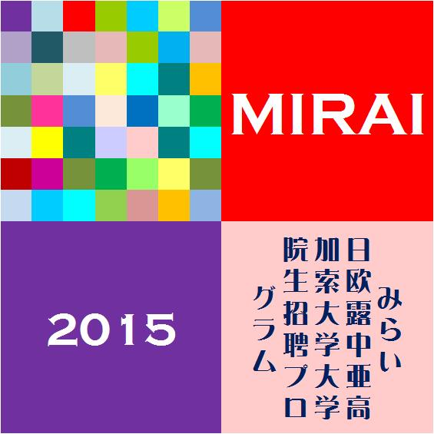

Press Release

Students invitation by MIRAI Program

1 From December 15th to 22nd, the government of Japan is inviting promising 150 graduate/undergraduate students from Europe, Russia, Central Asia and the Caucasus, including 1student from Kingdom of Denmark for MIRAI Program.

2 This invitation program, called MIRAI (Mutual-understanding, Intellectual Relations and Academic Exchange Initiative: MIRAI means “future” in Japanese) Program is starting this year.

3 During the stay, the students will visit and meet various responsible people in high-tech and traditional industries, leading companies, scientific and cultural sites; and governmental institutions.

4 They also visit a prestigious university in Tokyo, having lectures on Japanese politics, economy, society, history, culture and/or diplomatic policy from eminent professors followed by discussions with Japanese students.

5 The program includes homestay in regional towns and cities outside Tokyo.

Reference
1) Implementing Organization
AFS Japan (http://www.afs.or.jp)

